Subject: - Creation of resource pool of trainers for implementation of training component in Kashmir Government Polytechnic College, Srinagar under PM Vishwakarma Scheme.
Ref No: J&K Skill Development Mission Communication No: JKSDM/2024/94 dated: 12-02-2024.
Advertisement Notice
Applications are invited from the interested candidates for the Creation of a resource pool of trainers for undergoing training and certification through the NSDC / SSC PM Vishwakarma Training of Trainer (ToT) program and utilizing them for the training of Vishwakarma identified under the scheme in the following trade(s) based on Prescribed qualification mentioned against the trade. The ToT-certified applicants shall be utilized as per the requirements of the institution. Interested candidates need to submit their applications to this Office in the prescribed format forming Annexure “A” to this advertisement notice upto 02/03/2024 during working hours. In addition, they need to submit their details on the given Google form link/scanning the QR Code.

Google form Link:
https://forms.gle/wXeLsZ2nSkFzCQMv7 Scan QR

S.No | PM Vishwakarma Trade | Qualification
1. | Carpenter | - Candidate must possess prescribed qualifications as per the National Qualifications Register of GoI available on www.nqr.gov.in.  - Working knowledge of computer/ digital literacy is desirable for handling portal.  - NCVT/ SCVT ITI Certificate holder from a recognized institute shall also be considered.  - The candidates must fulfil specified criteria (as per NQR).  - Working knowledge of computer/ digital literacy is desirable for handling portal.  - Retired officials from Govt. Polytechnics/ ITIs having experience in relevant field shall be preferred.
2. | Brick Mason
3. | Tailor
4. | Hammer & Tool Kit maker
5. | Traditional Soft Toymaker

The duly completed Application Form in the prescribed format must be accompanied by the self-attested copies of the following certificates/documents.
1. Aadhaar Card
2. Academic/Technical Qualification Certificate/Marks Certificate.
3. Character Certificate duly signed by Gazette Officer.
4. Experience Certificate, if any.
5. Pan Card.
6. Domicile certificate.
Application forms can be downloaded from the official website of Institution: https://kgpsrinagar.edu.in.Incomplete application (not supported with documents) shall be rejected without any notice to the candidate.
- The utilization of shortlisted ToT-certified trainer shall be as per the requirement of the institute purely on a temporary basis.
- The remuneration shall be paid as per norms in vogue and funds under the scheme in this regard.
- The criteria for shortlisting of resource pool shall be observed the same as is followed for shortlisting Guest Instructors.
- The assignment of the resource person shall be discontinued without any prior notice whenever the undersigned desires or due to non-performance by the resource person or if the Vishwakarma’s are not available for training. The undersigned reserves the right to reject any application/candidature of a candidate or advertisement without assigning any reason thereof.
- The trainer shall have to maintain proper discipline and punctuality and shall have to work to the entire satisfaction of the Vishwakarma as well as the Head of the Institution.
- Indiscipline of any kind will entail discontinuation.
Mere submission of application or eligibility or conduct of ToT certification shall not entitle any candidate for this assignment.

No:- KGP/Estt/2024 Principal
Dated: /02/2024. Kashmir Govt. Polytechnic College
Srinagar
Copy to the: -
- Director Skill Development for information.
- Joint Director Information Kashmir with the request to kindly publish the notice in three leading newspapers for wide publicity.
- I/c College Website for upload.

ANNEXURE “A”
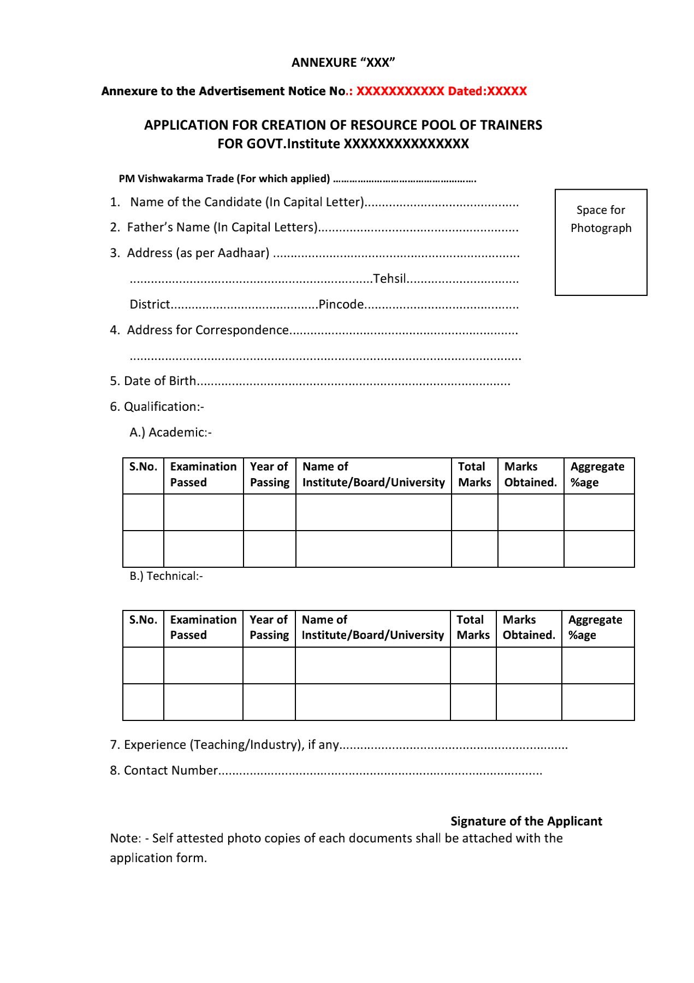
Annexure to the Advertisement Notice No:01- OF 2024, dated 24-02-2024

